Daily Screenshots
Day 1
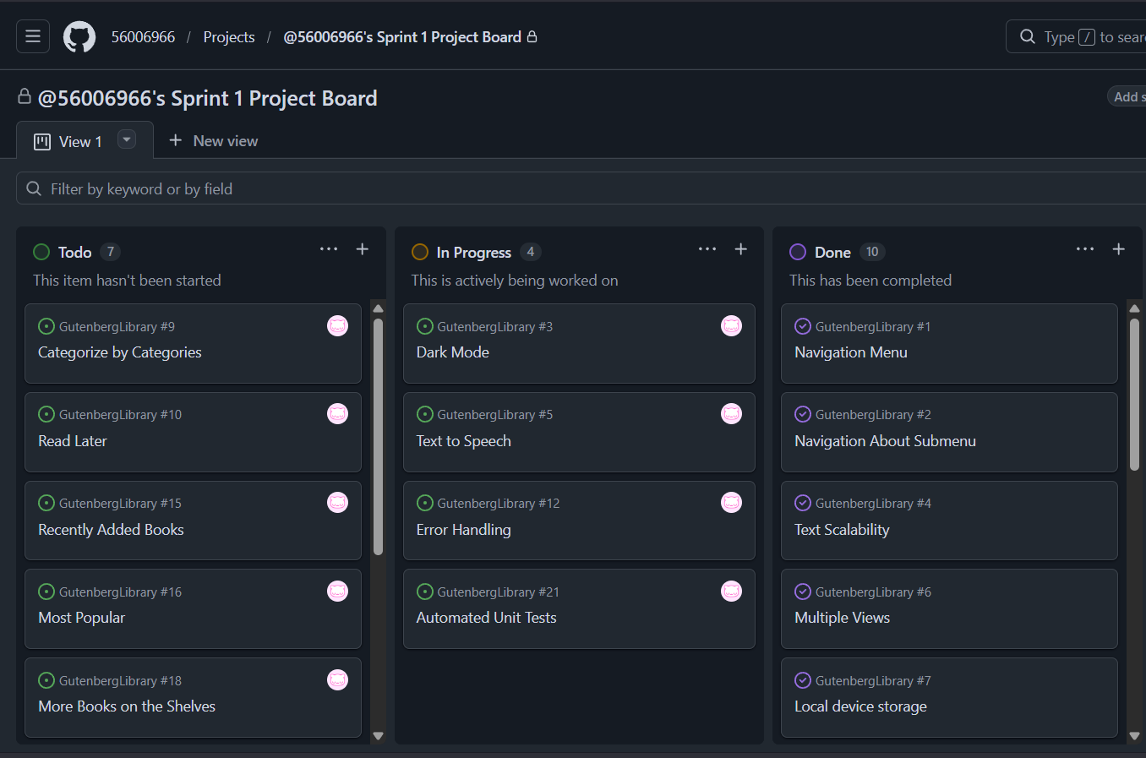
Day 2
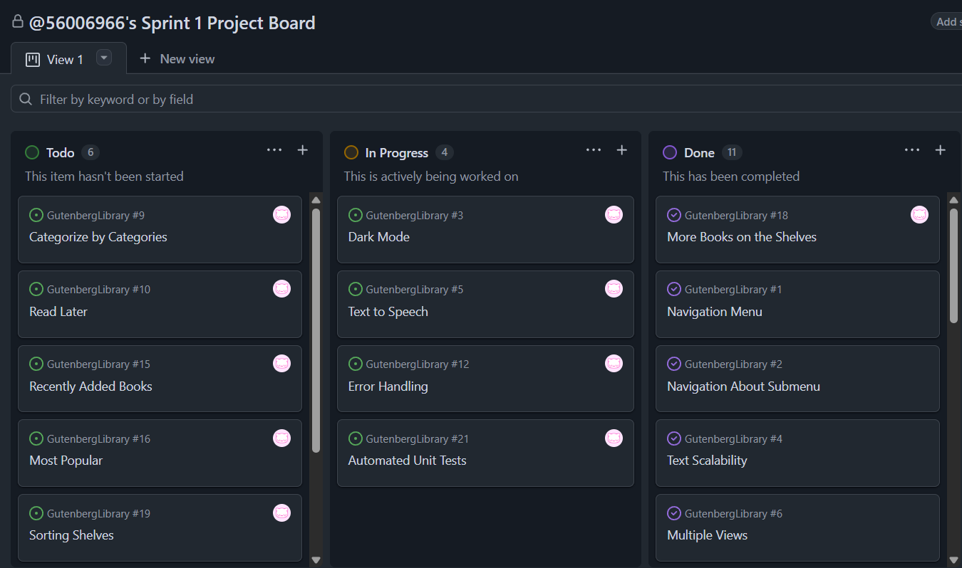
Day 3
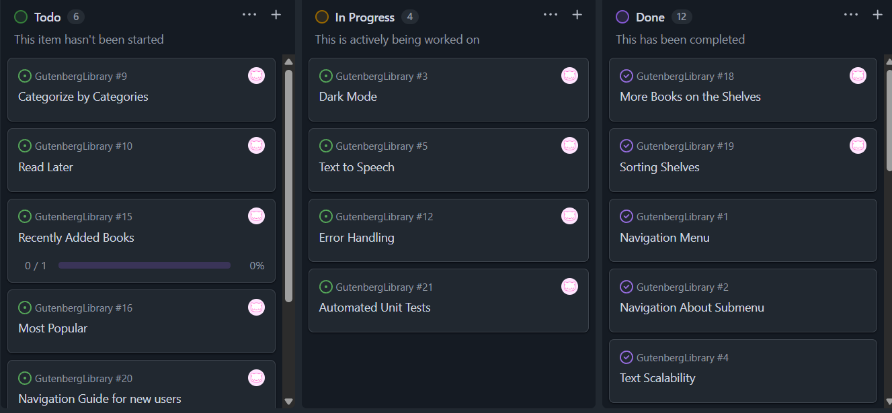
Day 4
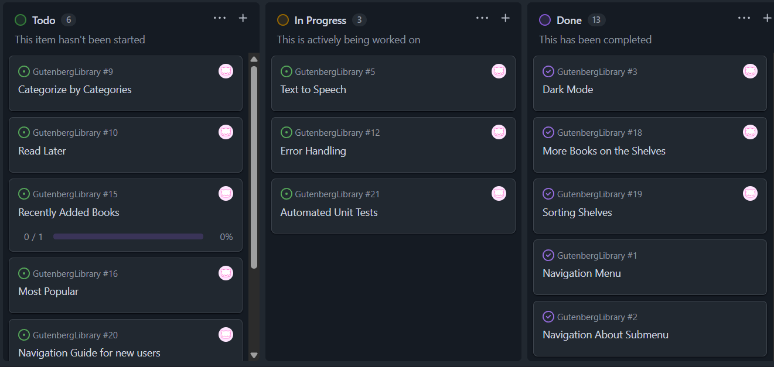
Day 5
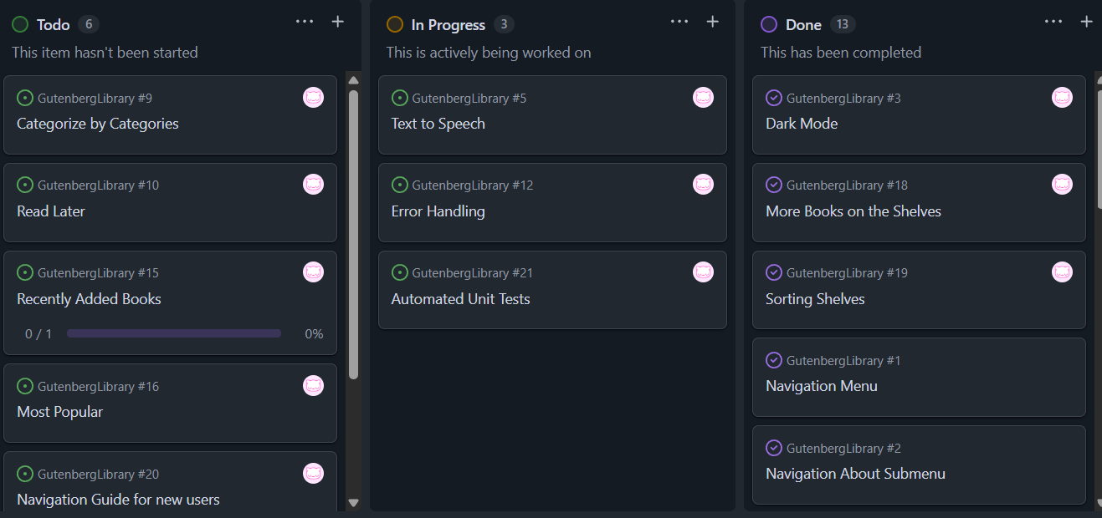
Day 6
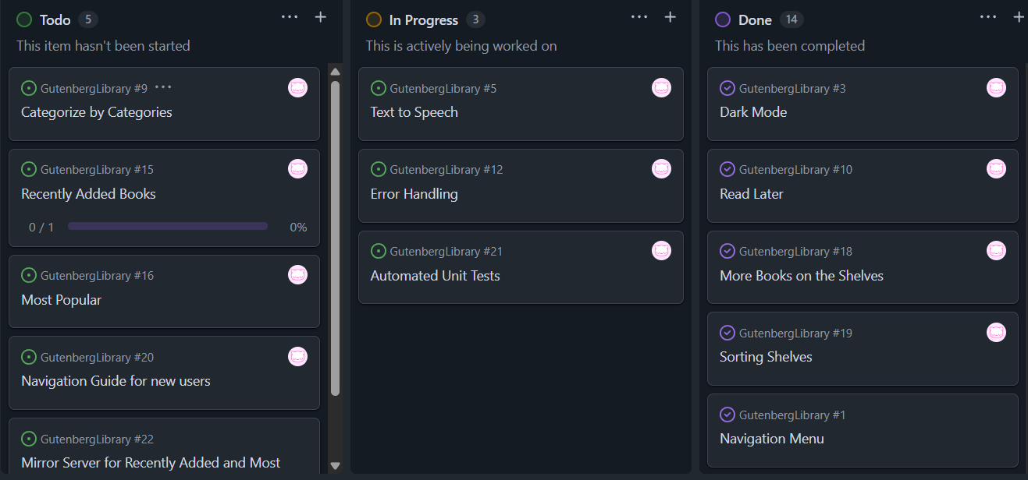
Day 7


Burndown Chart
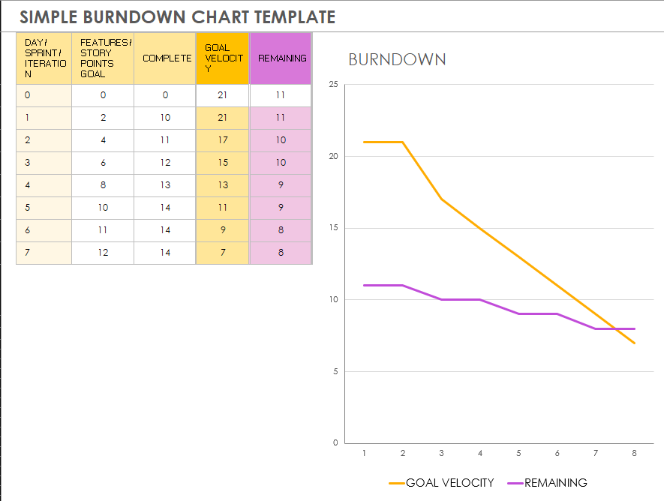

Sprint Review
- Did you complete all items in your sprint plan?
- What is your sprint deliverable? (shippable product(s))
- Did you have any task volatility, and what was the cause?
- What would you do differently knowing what you know now?
Note: This is a lessons learned page. It takes most teams several iterations of sprint planning and reviews before they start to get it right. Report what happened, not what should have happened.

Sprint Plan 2.0
